CSC5991 A2 Wei Zhou

Github location: <https://github.com/WeiZhou2/CSC5991A2>

Docker location: <https://hub.docker.com/repository/docker/jackjackzhou/csc5995a2>

For random local joke hit [http://127.0.0.1:5000/jokes](http://127.0.0.1:5000/jokes/)?num=10:

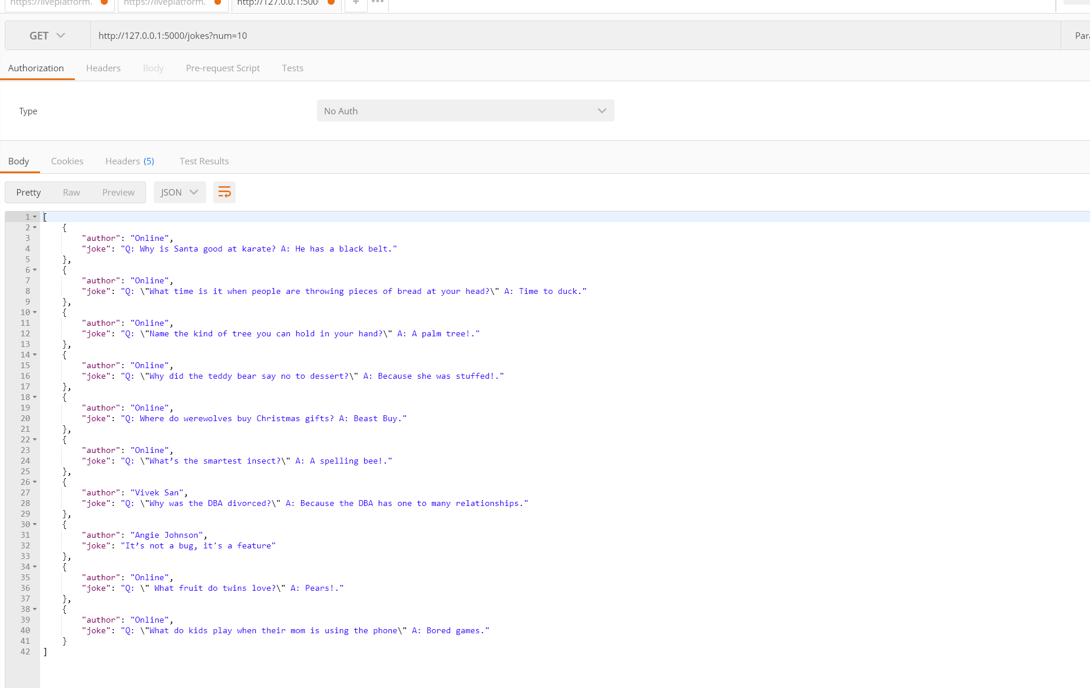

You also can get online jokes by getting jokes form jokeapi hit http://127.0.0.1:5000/online-jokes?num=10:

